**MST 1102- Introduction to Statistics WkSheet 4**

**(Last Name, First Name): ______________________________________________________________**

**Data Presentation II**

|  |  |  |  |  |
| --- | --- | --- | --- | --- |
| **Class** | **Class** | **Width** | **Midpoint** | **Frequency** |
| $$31-40$$ | $$30.5-40.5$$ | $$10$$ | $$35.5$$ | $$8$$ |
| $$41-50$$ | $$40.5-50.5$$ | $$10$$ | $$45.5$$ | $$35$$ |
| $$51-70$$ |  |  |  | $$10$$ |
| $$71-120$$ |  |  |  | $$4$$ |

1. Complete the table below by inserting the missing boundaries, widths and midpoints. **[6 marks]**
2. Use the frequency distribution table shown to the right to answer the questions below.

|  |  |
| --- | --- |
| **Weight** | **Frequency** |
| $$100-199$$ | $$2$$ |
| $$200-299$$ | $$10$$ |
| $$300-399$$ | $$6$$ |
| $$400-499$$ | $$18$$ |
| $$500-699$$ | $$13$$ |
| $$700-999$$ | $$3$$ |

1. Is the frequency table group or ungroup? Explain. **[2 marks]**

________________________________________________________________________________________

________________________________________________________________________________________

1. What is the lower class limit of the $3^{rd}$ class? _______________________ **[1 mark]**
2. What is the upper class limit of the $5^{th}$ class? _______________________ **[1 mark]**
3. What is the lower class boundary of the $2^{nd}$ class? _________________ **[1 mark]**
4. What is the upper class boundary of the $4^{th}$ class? __________________ **[1 mark]**
5. What is the width of the final class? __________________________ **[1 mark]**
6. What is the midpoint of the $1^{st}$ class? _______________________ **[1 mark]**
7. These data represent the record high temperatures in degrees Fahrenheit (oF) for each of the 50 states. Construct a grouped frequency distribution for the data. [Headings: Temp (class), boundaries, tally, frequency] **[7 marks]**

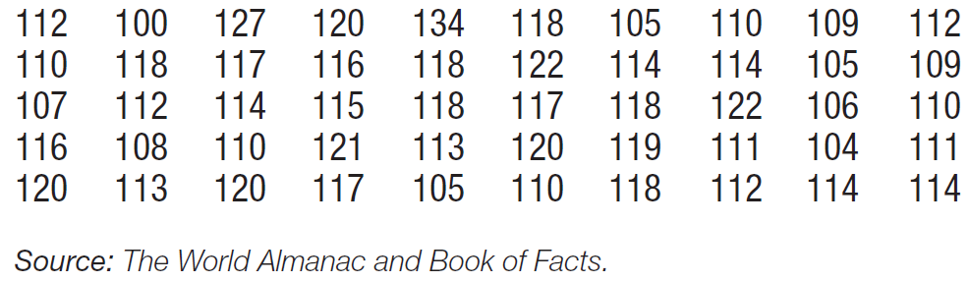

|  |  |  |  |
| --- | --- | --- | --- |
|  |  |  |  |
|  |  |  |  |
|  |  |  |  |
|  |  |  |  |
|  |  |  |  |
|  |  |  |  |
|  |  |  |  |

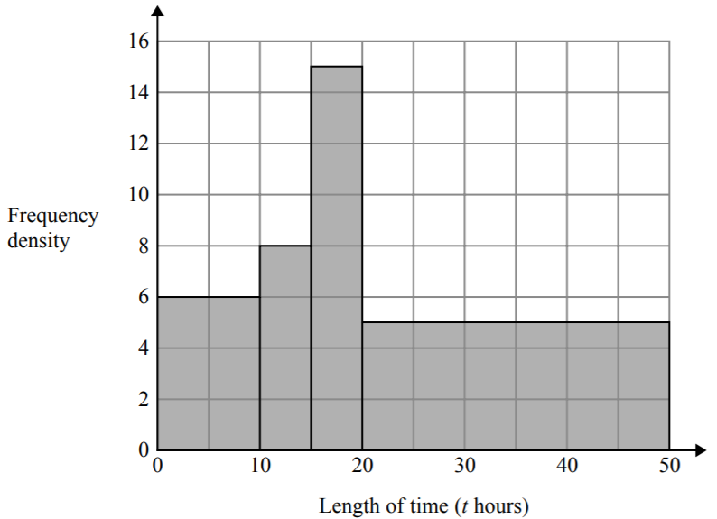

1. Asaad recorded the lengths of time, in hours, that some adults watched TV last week. The table shows the information about his results. Asaad made some mistakes when he drew a histogram for this information. Write down two mistakes Asaad made.

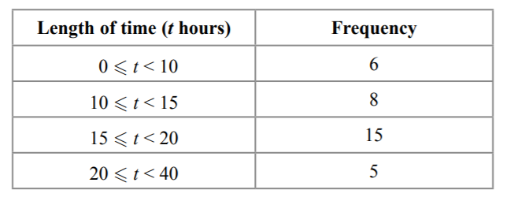

Mistake 1: ________________________________________________________________________________________________________________ **[1 mark]**

Mistake 2: ________________________________________________________________________________________________________________ [**1 mark]**

1. The table gives information about the heights, ℎ metres, of trees in a forest. Draw a histogram to show this information. **[4 marks]**

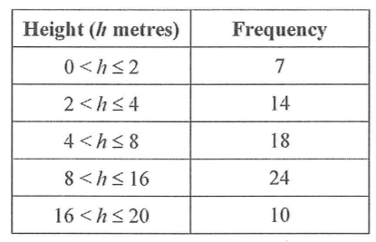

1. A train company records the number of minutes, 𝑡, some trains were late in one month. The histogram summarizes the results. How many trains were more than 15 minutes late? **[3 marks]**

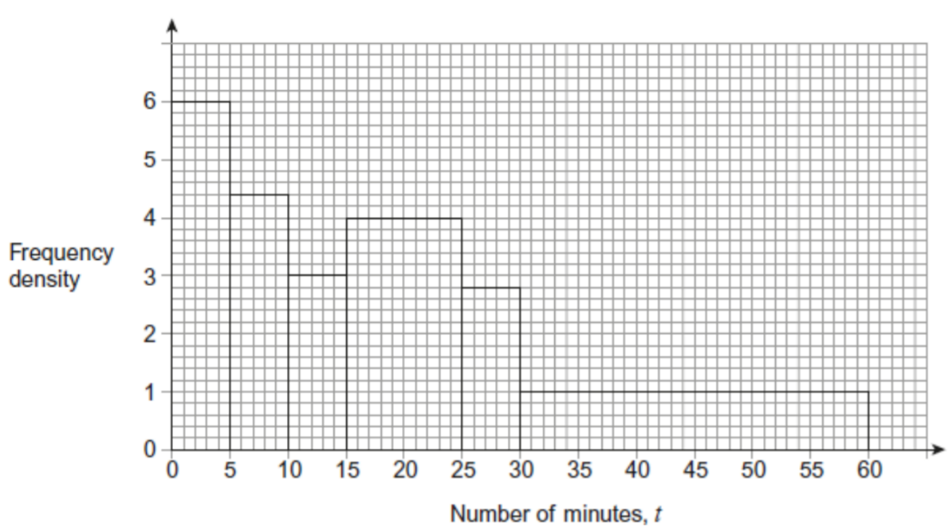

1. 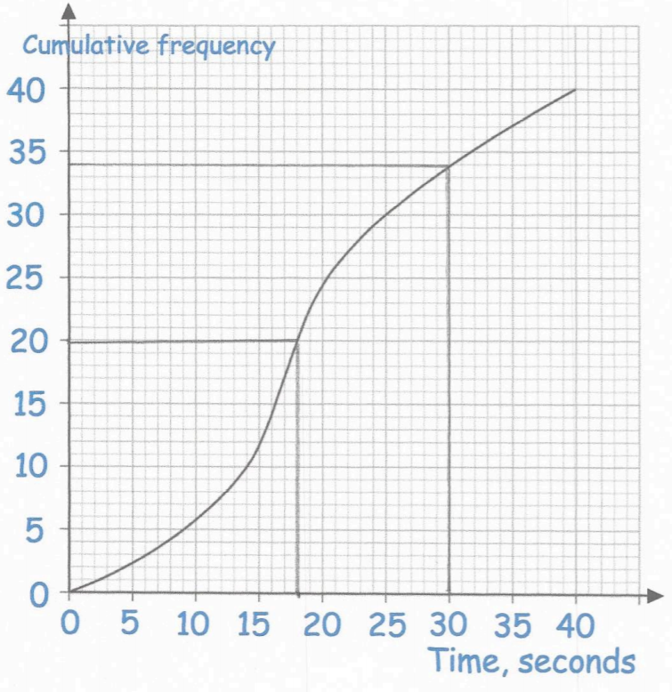The graph on the right shows information about the time taken by 40 people to solve a puzzle.
2. How many people took less than 30 seconds?

_______________________________________________ **[1 mark]**

1. How many people took less than 10 seconds?

________________________________________________ **[1 mark]**

1. How many people took longer than 25 seconds?

________________________________________________ **[1 mark]**

1. How many people took longer than 35 seconds?

________________________________________________ **[1 mark]**

1. The fastest 10 people completed the puzzle under how many seconds?

_______________________________________________ **[1 mark]**

1. Show that less than 20% of people completed took longer than 30 seconds. **[2 marks]**

**Total: 37 marks**